TES AKHIR MODUL 8

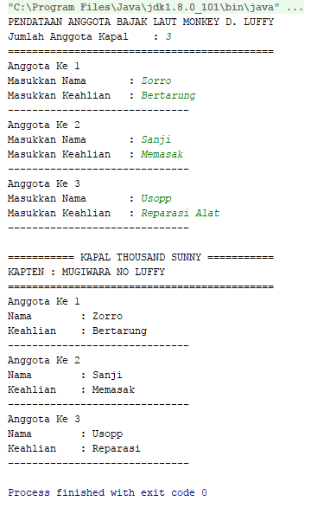

Yee... tidak ngoding, tapi Fill in the Blank :D

**LENGKAPI CODE DI BAWAH INI AGAR BISA MENAMPILKAN PROGRAM SEPERTI CONTOH DI ATAS !!!!!**

HINT : Soal ada di ***TODO Code Here***

**package** id.amirisback.bandung;  
**import** java.util.Scanner;  
**public class** Main {  
 **static class** (1)....... { // TODO Code Here (1Point)  
 String **nama**;  
 String **keahlian**;  
 }  
 **public static void** main(String[] args) {  
 *// write your code here* Scanner in = **new** Scanner(System.***in***);  
 String kapten = **"MONKEY D. LUFFY"**;  
 System.***out***.println(**"PENDATAAN ANGGOTA BAJAK LAUT "** + kapten);  
 System.***out***.print(**"Jumlah Anggota Kapal \t: "**);  
 **int** luas = in.nextInt();  
 System.***out***.println(**"============================================"**);  
 Anggota (2)........ = **new** Anggota[luas]; // TODO Code Here (3Point)  
 **for** (**int** i = 0; i < luas; i++) {  
 Anggota (3)....... = **new** Anggota(); // TODO Code Here (3Point)  
 System.***out***.println(**"Anggota Ke "** + (i + 1));  
 System.***out***.print(**"Masukkan Nama \t\t: "**);  
 awak.**nama** = in.next();  
 System.***out***.print(**"Masukkan Keahlian \t: "**);  
 awak.**keahlian** = in.next();  
 Array[i] = awak;  
 System.***out***.println(**"------------------------------"**);  
 }  
 System.***out***.println();

String Julukan = kapten.(4).........(**"MONKEY D."**, **"MUGIWARA NO"**);// TODO Code Here (3Point)

System.***out***.println(**"=========== KAPAL THOUSAND SUNNY ==========="**);  
 System.***out***.println(**"KAPTEN : "** + Julukan);  
 System.***out***.println(**"============================================"**);  
 **for** (**int** i = 0; i < luas; i++) {  
 System.***out***.println(**"Anggota Ke "** + (i + 1));  
 System.***out***.println(**"Nama \t\t: "** + Array[i].**nama**);

System.***out***.println(**"Keahlian \t: "** + Array[i].**(5).......**); // TODO Code Here (3Point)

System.***out***.println(**"------------------------------"**);  
 }  
 }  
}

6. Apa yang kalian dapatkan dari Praktikum Modul 8 ?? // (2Point)